**VPC PEERING SETUP REGION TO REGION**

N.VIRGINIA

Step1 : Login the AWS Console

<https://us-east-1.console.aws.amazon.com/console/home?region=us-east>

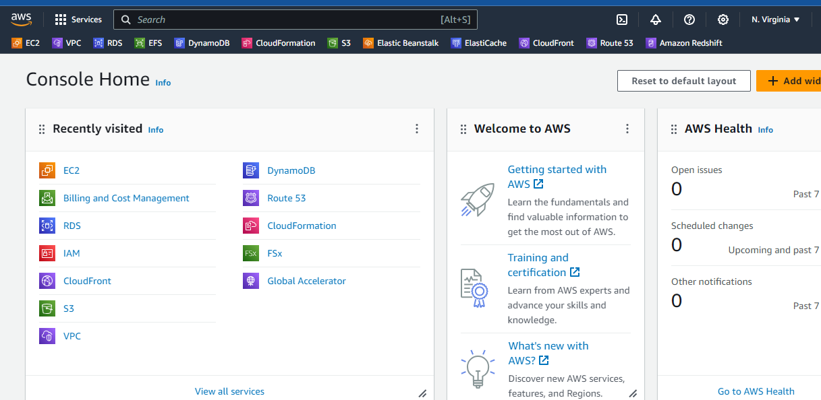

Step2 : Goto vpc create a new vpc in n.virginia

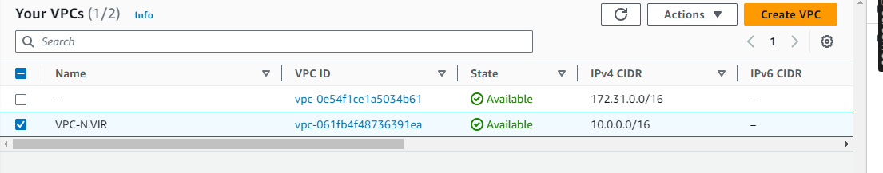

Step3 : Next create a subnet in n.virginia

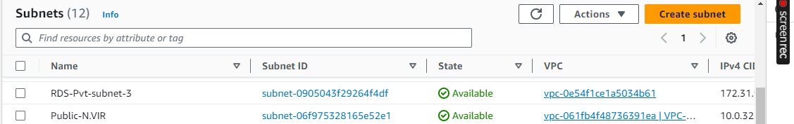

Step4 : Next create a internet gate way then select igw click action next

then choose your vpc in igw click save

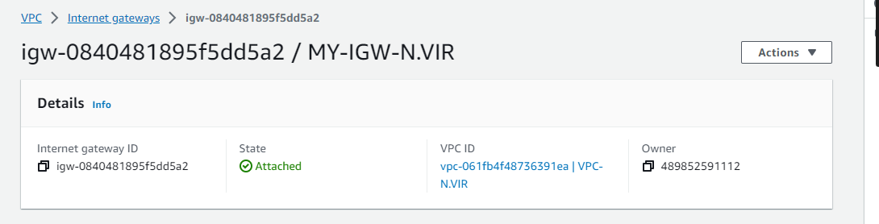

Step5 : Next create a route table n.virginia then click route table edit route destination 0.0...

and target select igw then save. click edit subnet associations select your subnet save

the route

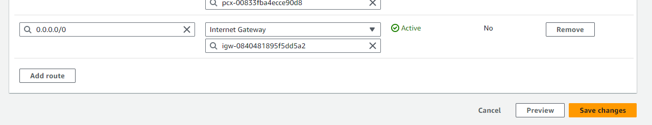

Step6 : Goto ec2 instance create the instance Choose an Amazon Machine Image (AMI) based on your preferred operating system.

Step7 : Configure the instance details, including instance type, VPC ( choose the new vpc) , subnet (public subnet) , and security group.

Step8 : Review your settings and launch the instance.

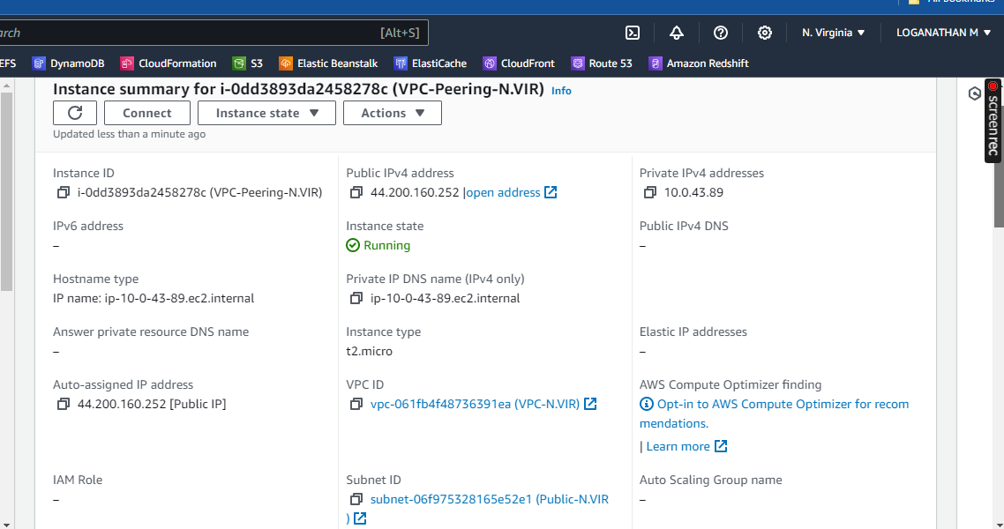

MUMBAI

Step9 : Goto vpc create a new vpc in mumbai

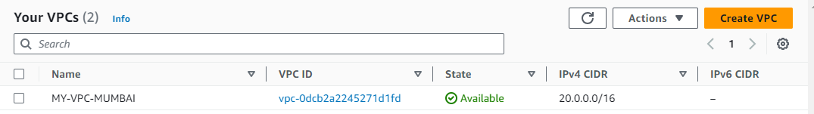

Step10 : Next create a subnet in mumbai

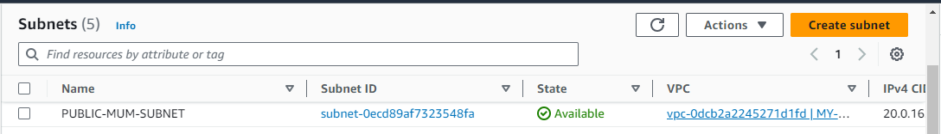

Step11 : Next create a internet gate way then select igw click action next

then choose your vpc in igw click save

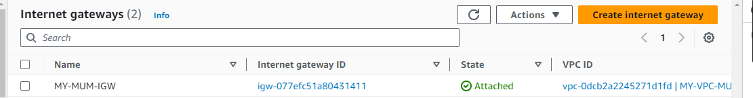

Step12 : Next create a route table n.virginia then click route table edit route destination 0.0...

and target

select igw then save. click edit subnet associations select your subnet save the route

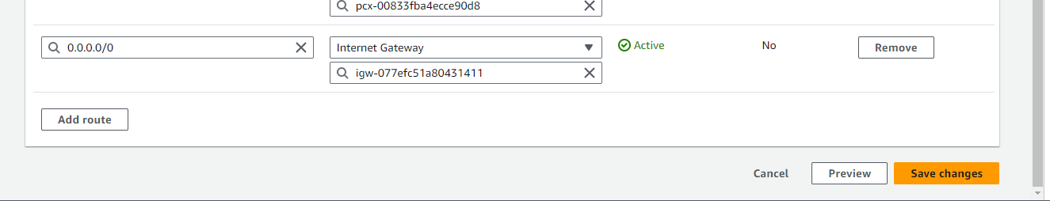

Step13 : Goto ec2 instance create the instance Choose an Amazon Machine Image (AMI) based on your preferred operating system.

Step14 : Configure the instance details, including instance type, VPC ( choose the new vpc) , subnet (public subnet) , and security group.

Step15 : Review your settings and launch the instance.

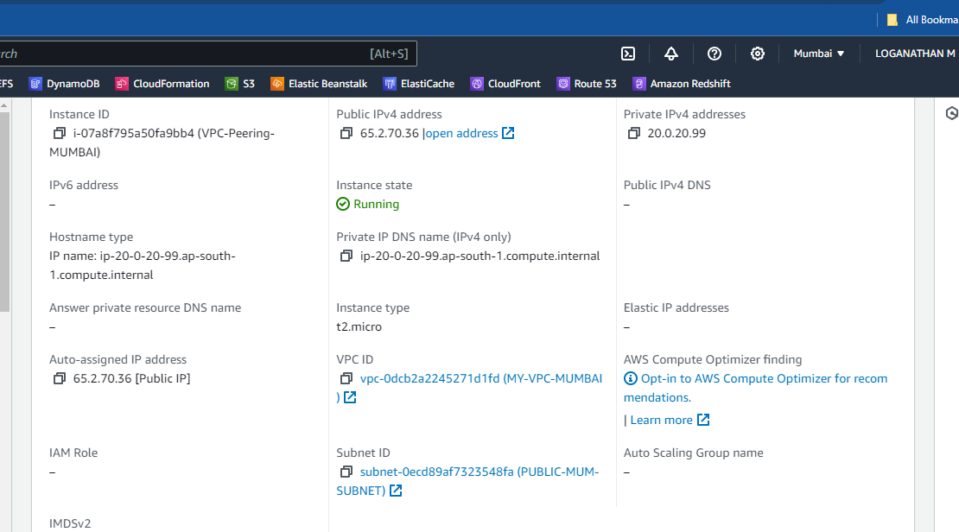

Step16 : Next goto vpc in n.virginia click peering connections select vpc id ( requester)

choose your vpc next

scroll down select another vpc peer with select another account vpc id (accepter)

select mumbai region vpc id then save.

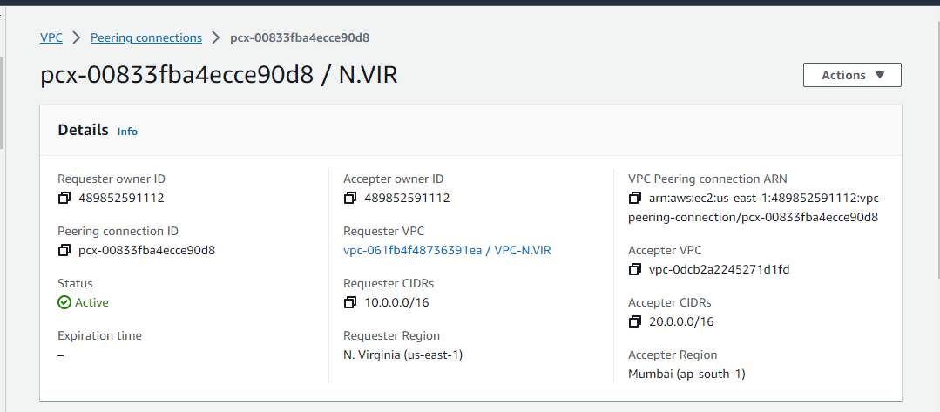

Step17 : Next goto vpc mumbai region select peering connections then one request shows in your side select then accept respond

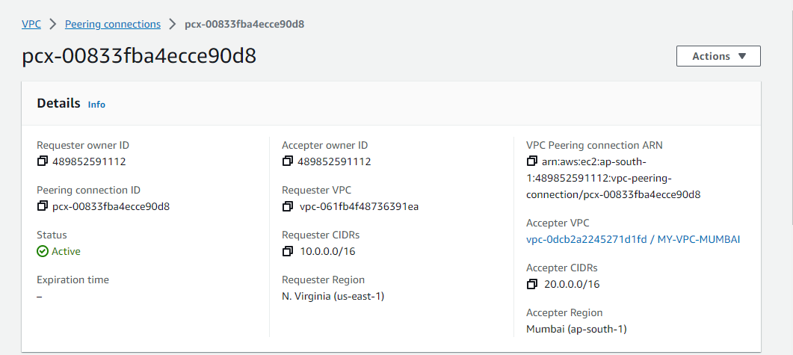

Step18 : Both sides are connection is peering

Step19 : Next goto route table in mumbai region edit route click destinstion choose for

n.virigina vpc id then target peering connection

click then select . then save the edit route table

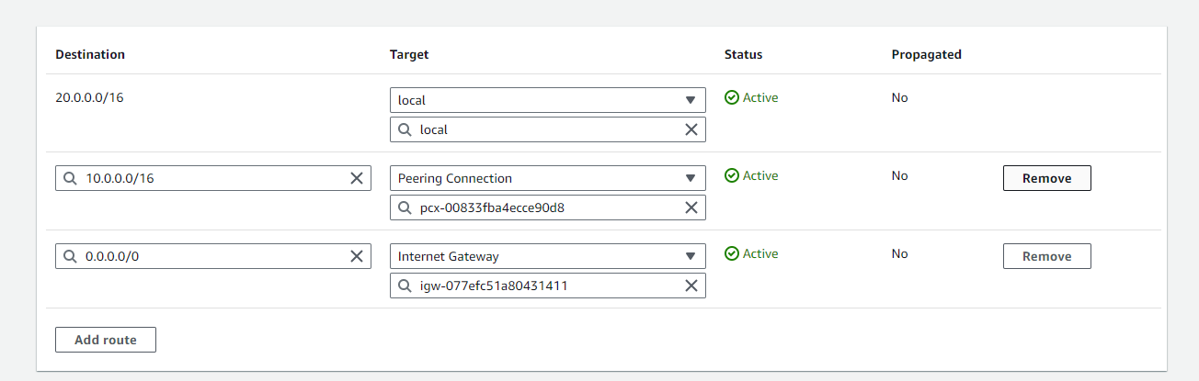

Step20 : Next goto route table in n.viriginia region edit route click destinstion choose for mumbai vpc id then target peering connection

click then select . then save the edit route table

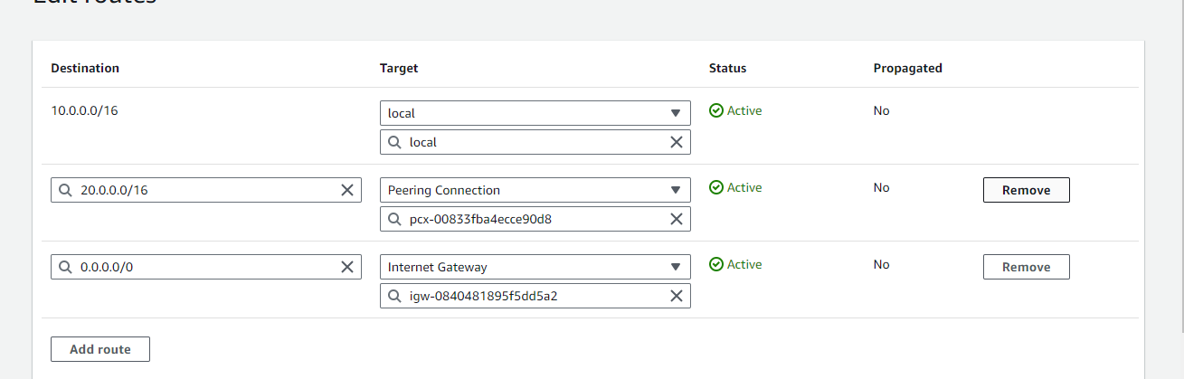

Step21 : Next connecting instance in n.virginia connect the server in putty

$ ping private instance id ( mumbai region )

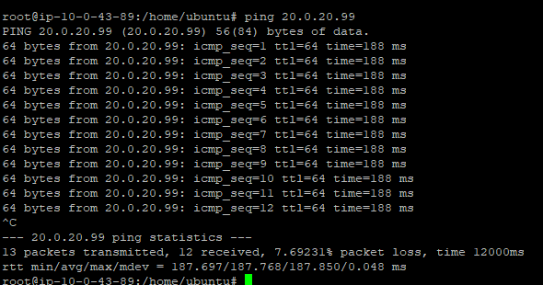

Step22 : connecting the mumbai region instance

Step23 : Next connecting instance in mumbai region connect the server in putty

$ ping private instance id ( n.virginia )

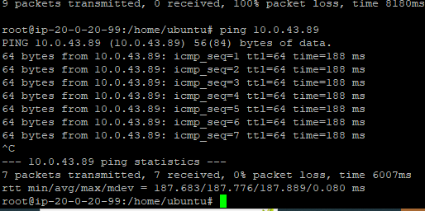

Step24 : Both instance are running